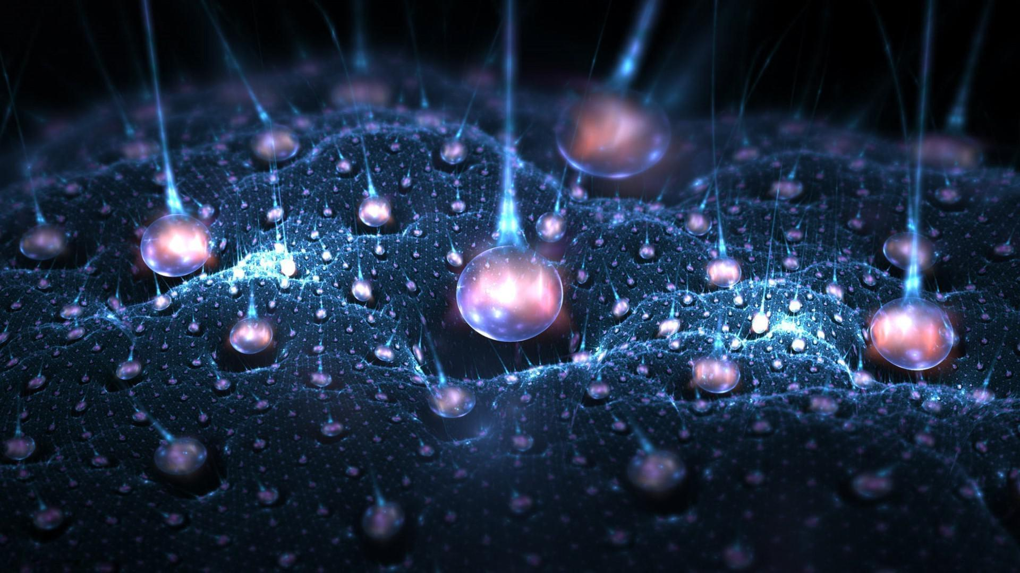
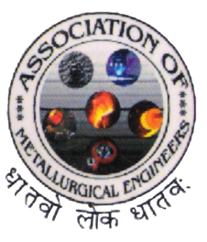
JNTUH College of Engineering, Hyderabad
Department of Metallurgical Engineering
December 2018
Volume 4 Issue 1

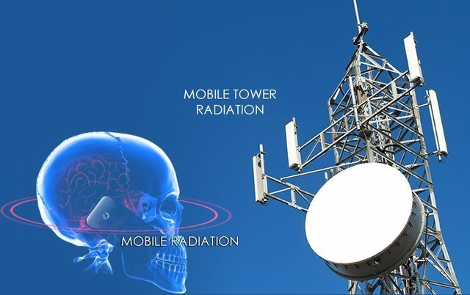
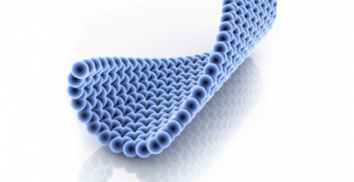
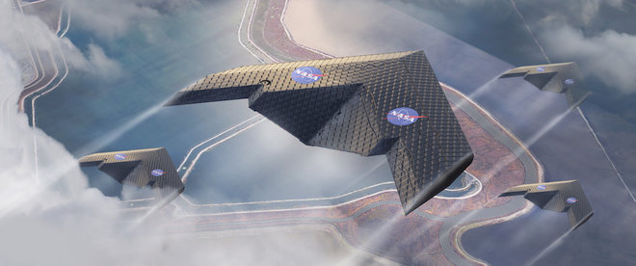
VISION OF THE DEPARTMENT
To impart quality education in Metallurgical Engineering and constantly pursuing excellence by upgrading knowledge skills and attitude useful to Industry, Academic and Society.
MISSION OF THE DEPARTMENT
1. To produce graduates having professional excellence in Basic Sciences and Metallurgical Engineering with concern towards society.
2. To provide a scientific environment, to help meet the desires and needs of students and faculty for enhancing research efforts and technological innovations.
3. To provide technical support to higher education, industry and R&D units.
ABOUT THE DEPARTMENT
Welcome to the Department of Metallurgical Engineering of JNTU College of Engineering Hyderabad, where experienced faculties and highly motivated students - supported by a dedicated staffs - experience a unique engineering education.
The B.Tech in Metallurgical Engineering was started in 1989.The Department started functioning independently from 1992. Now the Department has a separate building shared with well-established labs. The Department is growing steadily and has its own Computer laboratory besides the Departmental Library. The department is also offering the following programmes, Ph.D – Part Time (Metallurgical Engineering), and PG - Part Time (Industrial Metallurgy) started in the year 2010.
Our faculty members have a passion for teaching and an avowed commitment to research and development. We are continually striving to improve the quality of our programs by finding new ways of structuring our curriculum and exploring new delivery methods.
We provide our students opportunities to engage in experiments, project work, industrial training, seminars, and team work to enhance the learning process that is so vital for a holistic engineering education. This new letter highlights the students and faculty achievements in the odd and even semester of academic year 2018-2019.

INSIDE

- Events Conducted By The Department …4
- Equipment Acquired By Department …4
- Furniture …4
- Computers …5
- Articles
    - Recycling Of Gold From E-Waste …6
    - Energy Neutral Mineral Processing …6
    - Cell Tower Radiation …7
    - Honey Is The Best …8
    - Importance Of Languages …8
    - You, As An Element In Matrix …9
- Smruthi …9

Events Conducted By the Department:

S.No | Event | Date | Descriptions
1. | Silver jubilee  Metallica 25 | 8/7/2018 | 125 – 150 Alumina students participated.
2. | SMRUTHI | 17/09/2018 | 100-125 students participated  Cricket, basket ball, volleyball, throw ball, chess, caroms sports events conducted.
3. | Expert Lecture on Indigenization of Hafnium for Space and Atomic Energy Applications - from Ore to Metal | 28/09/2018  Dr. Raghu C Reddy, Scientist ‘E’,  CMET | 66 students participated.
4. | Expert Lecture on Modelling the Effect of Infrared Treatment on the Properties of Cold Sprayed Coatings | 23/11/2018  Dr. D.V.V. Satyanarayana, Scientist -“G”, Group Head, MBG,DMRL | 60 students participated.

Equipment Acquired By Department
Sl.no | Date | Name of the Equipment | Qty | Price (Rs.) | Fund
1 | 20.07.2018 | Analytical balance | 1 | 1,83,750/- | TEQIP-III
2 | 08.08.2018 | 10KVA UPS | 1 | 3,88,290/- | TEQIP-III
3 |  | Luminous 3.5 KVA inverter | 1
4 |  | Luminous 2 KVA inverter | 1
6 | 29.08.2018 | Magnetic separator | 1 | 1,87,719/- | TEQIP-III
7 | 23.10.2018 | MIG Welding machine | 1 | 2,24,175/- | TEQIP-III
8 | 23.10.2018 | Submerged arc welding machine | 1 | 3,66,975/- | TEQIP-III
9 | 23.10.2018 | Plasma cutting machine | 1 | 1,63,275/- | TEQIP-III
Furniture
Sl.no | Date | Name of the Furniture | Qty | Price (Rs.) | Fund
1 | 24.08.2018 | Magnetic green chalk writing board | 1 | 8,496/- | CDF
Computers
Sl.no | Date | Name of the Computer | Qty | Price (Rs.) | Fund
1 | 15.10.2018 | Dell optiplex 7050 MT desktop | 11 | 7,74,716.00 | TEQIP-III
2 | 22.11.2018 | HP Prodesk 600 G4 MT Desktops,  P.No. 2VE73AV | 10 | 4,45,200.00 | RUSA funds  (Given by Principal office)
Total |  |  |  | 12,19,916.00

-Articles-
1. Recycling of Gold from E-waste
A new process for the Recovery of Gold from Electronic Waste, by using Hydro metallurgical methods. E-waste (or) Electronic Waste is defined as “discarded electrical (or) electronic devices”. Generally, e-waste contains some heavy metals and Hazardous substances such as gold, silver, lead, cadmium etc. E-waste management has become a great challenge in the world. The need of recycling is, it will reduce the pressure on natural resources and it will reduce the environmental contamination.
Some precious metals like gold can be recycled from Mobile phones, as each mobile phone's CPU system is made up of gold and some other precious metals. Gold can be recycled by using two methods. They are Hydro metallurgical methods and Pyro metallurgical methods. But Hydro metallurgical methods are economically more attractive than the Pyro metallurgical methods. Hydro metallurgical methods consist of six steps. They are
- Grinding of CPUs
- Leaching in Nitric acid
- Leaching in Aqua media
- Removing of excess Nitric acid
- Gold precipitation
- Washing, purifying and drying of gold deposits
The pure form of gold is formed after these steps. This recycled gold can be used in jewelry making, medals, trophies and other purposes. The advantage of recycling is, in order to reduce the environmental pollution, and human health effects. And it’s the most effective solution to the growing of e-waste problems in the World.
G.PAVANI (15011A0623)
2. Energy Neutral Mineral Processing
A number of primary ores such as phosphate rock, gold, copper, and rare earth ones contain considerable amounts of accompanying uranium andcritical materilas.Energy neutral mineral processing is the extraction of unconventional uranium ( and/or thorium ) during primary ore processing for use as raw material to produce nuclear re- actor fuel. Energy neutrality is reached if the extracted unconventional uranium is used to generate energy equivalent to or larger than the amount of energy required for min- eral processing of the primary ore and uranium extraction, conversion, enrichment and fuel production.
Extracted uranium, usually shipped as uranium ore concentrate (UOC), can be sent as uranium conversion/enrichment and later nuclear fuel production at a nuclear fuel manufacturer in the same way traditional uranium mines handdle their product. The effeciency of energy neutral mineral processing may further be enhanced if the energy source is deployed in the vicinity of the processing plant and even more so if used to directly supply process heat for energy intensive mineral ore development and /or sup- porting energy intensive operations such as water desalination.
AYINAM SAI RISHABH NAIDU (15011A0635)

3. Cell Tower Radiation
Cell phone technology has revolutionized the telecommunication scenario in India. Due to its several advantages, cell phone technology has grown exponentially in the last decade. Currently, there are more than 50 crore cell phone users and nearly 4.4 lakh cell phone towers to meet the communication demand. All over the world, people have been debating about associated health risk due to radiation from cell phone and cell tower. Radiation effects are divided into thermal and non-thermal effects. Thermal effects are similar to that of cooking in the microwave oven. Non-thermal effects are not well defined but it has been reported that, non-thermal effects are 3 to 4 times more harmful than thermal effects.
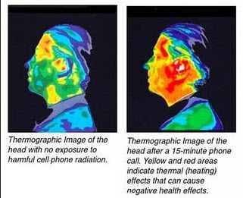
A cell phone transmits 1 to 2 Watt of power in the frequency range of 824 - 849 MHz (CDMA), 890 - 915 MHz (GSM900) and 1710 – 1780 MHz (GSM1800). A cell phone has a SAR (Specific Absorption Rate) rating. In USA, SAR limit for cell phones is 1.6W/Kg which is actually for 6 minutes per day usage. It has a safety margin of 3 to 4, so a person should not use cell phone for more than 18 to 24 minutes per day. People in India do not commonly know this information. Also many cases are in pending in courts w.r.t brain tumours and cancer due to cell towers. Mr. Bhagwant Deshpande of Solapur has reported 9 deaths due to cancer living within 91m from the two towers and Sudhir Kasliwal of Jaipur lost his two brothers with brain tumour living within 20meters from the tower. So crores of people use cell phones for more than an hour per day without realizing it.
Cell operators continue to claim that there are no health issues. Even organizations like WHO, ICNIRP, FCC, etc. have not recommended stricter safe radiation guidelines. Cell phone industry is becoming another cigarette industry, which kept claiming that smoking is not harmful and now there are millions of people around the world who have suffer from smoking. In fact, cell phone/tower radiation is worse than smoking; as one cannot see it or smell it, and its effect on health is noted after a long period of exposure. Unfortunately, ignorance and non-awareness adds to this misery and all of us are absorbing this slow poison unknowingly. Even if people are aware of the radiation hazard, they may not have the choice to move away from it if the tower is installed near their office or residential building. In addition to the continuous radiation from cell towers, there is radiation from cell phones, wireless phones, computers, laptops, TV towers, FM towers, AM towers, microwave ovens, etc. We are exposed to all these radiations which are additive in nature. Hence, it is imperative that stricter radiation norms must be enforced by the policy makers.
This does not mean that we have to stop living near these towers. We all know that automobiles create air pollution – have we stopped using them? Instead, solutions were found such as unleaded petrol, catalytic converters to reduce emission, CNG driven vehicles, hybrid vehicles, etc. If people in the mobile companies think there is no health hazard, then let them stand in front of their own transmitting tower at 1m distance in the main beam for 6 hours – are they willing to take the risk? Similar effect will be there at 10m distance in about 600 hours (25 days). If mobile companies accept that radiation causes serious health problems, will people stop using cell phones? Not really, because the cell technology has its several advantages. However, then researchers/technocrats/entrepreneurs will come out with possible solutions, which may be expensive but that cannot be greater than the health risk faced by humans, birds, animals and environment.
P.PRUDHVEE (14011A0631)
4. “HONEY IS THE BEST”
Since ancient times, people used honey as both food and a medicine. It offers several health benefits. Sugar has 100% empty calories. Honey contains some nutrients; 1table spoon of honey (21 grams) contains 64 calories and 17 grams of sugar, including glucose and fructose. If contains no fat. Honey contains many important antioxidants. These include organic acids and phenolic compounds. These increase value of blood and also promote eye health. Honey is better than refined sugar for people with diabetes, but still consumed with caution only. It reduces blood pressure and cures heart disease. Also helps improve cholesterol. When applied to the skin, honey can be part of an effective treatment plan for burns, wounds and many other skin conditions. It helps in suppress coughs in children. But below one year child is not given due to risk for botulism, because they cannot swallow as honey will be thick. It is a traditional medicine in ayurveda. It prevents metabolic stress and boosts your memory. It’s a natural remedy for dandruff. It gives smooth and soft hair. All we need to do is mix 2 tablespoons of Dabur honey with equal amount of vegetable oil and apply it on your hair. Keep this hair mask on for 15 minutes and rise it off before you shampoo. Some of the homemade remedies or benefits and home medication tips are given below:
- One hour before lunch, mix 2 spoons of honey in a glass water and have it. It makes us feel hungry. This is best for children who are stubborn to eat.
- Mix honey in one glass of water and have it in the evening. It gives peaceful sleep.
- The people who are fat should mix 2 spoons of honey in hot water and have it daily. You can observe change within 2 months.
- People who are suffering from constipation(indigestion),by waking up in the morning itself take one glass of cold water and mix one spoon of honey in water. Have it daily.
- If cold and cough, add honey in milk or tea and have it. It stops your burden in head.
- Mix honey in ginger decoction and have it. This is a tip if more cough or irritating cough inside the throat.
B.DURGA SRIVANI (15011A0613)
5. Importance of Languages
With the evolution of human race and with humans becoming intelligent by the day, the most important means for the communication of human thoughts is the “LANGUAGE” emerged. In the early stages, human got through by using body language and expression but complex explanations and expressions could not be communicated. Hence, it became important to devise a language for better communication and for better interpretation.

As the proverb goes, “Necessity is the mother of invention". Languages have evolved over the ages as per the need and convenience of people. Though language remains as a barrier to different language speakers, it also acts as the bridge to speakers of different nations. Culture of a particular region can also be deciphered by the language. The way of speech of a person reveals the character and attitude of that person.

While they help in communication with other people, the various kinds of exposure to knowledge of the brain expands with the various understandings of languages. The means people acquire knowledge may be through study, through auditory assistance, through voluntary speech, and many other ways, These means pave ways to understanding languages a well as engages our mind and soul in divergent ways where we can break the pinnacle of human potential. Thus, language serves different purposes and is an inevitable auxiliary of every human’s life.
K.S.ANEESHA(15011A0641)
6. You, As An Element In Matrix
No one wins anything without the help from family and friends who steer you away from bad ideas and towards the good things. Because everytime anyone accomplishes anything he or she achieves it with the help of the thousand silent heroes. The selfless team players who offer their support not to be recognized, but because it is the right thing to do. We are living in the land where people of vastly different cultures are brought together by their willingness to work hard and their desire to succeed.
Sometimes life can be simpler than we think, we are born; we die and in between if we are lucky we laugh with the people closer to us which makes the journey worth taking.
V. SUMEDHA (15011A0645)
SMRUTHI 2018
Smruthi is a college wide sports event conducted in the memory of Late. M. Swathi who was a student of metallurgical engineering at JNTUHCEH. She passed away due to a viral fever. She was a talented individual and worked hard to get an admission into JNTUHCEH, her dream was to become a successful metallurgist. The department of Metallurgical Engineering remembers her efforts and dedication towards education and conducts SMRUTHI in the month of October ever year. This event is dedicated to raise awareness on health and hygiene amongst the youngster and students on JNTUH. The department is conducting events like sports, extra-curricular activities and help the orphans with the money raised in these actives, and conducting blood bank donation camps.
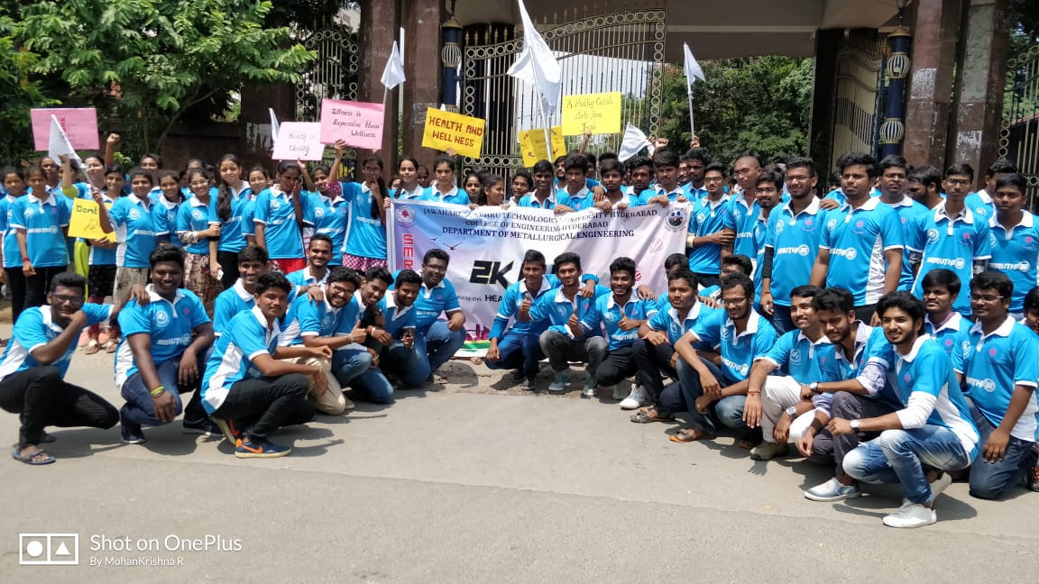
Inauguration rally for SMRUTHI 2K18

